**jboss-eap-6.4.0.zip**

1) 자바 설정

**set JAVA_HOME=C:\Program Files\Java\jdk1.6.0_45**

2) jboss 실행

C:\dev\jboss-eap-6.4\bin\**standalone.bat**

3) 관리자 추가

C:\dev\jboss-eap-6.4\bin\**add-user.bat** (mgmt-users.properties에서 변화 있음)

* 비밀번호는 알파벳1개 이상, 숫자 1개이상, 특수문자 1개이상) admin/kms0827!

<http://127.0.0.1:9990/> 🡪 <http://127.0.0.1:9990/console/> (add-user에서 지정한 user/password)

4) 관리 콘솔에서 배포

<http://127.0.0.1:9990/console/App.html#home>

Deployments 🡪 add 🡪 war 파일 선택

◈ 전자정부프레임워크 war 선택시 주의사항

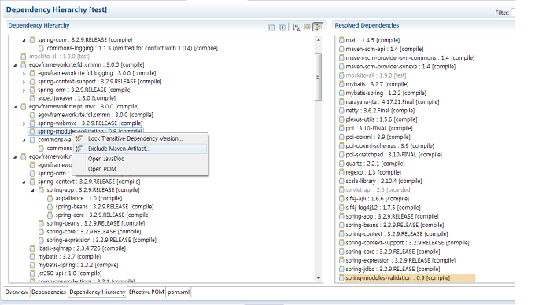pom.xml 에서 제외

<dependency>

<groupId>egovframework.rte</groupId>

<artifactId>egovframework.rte.ptl.mvc</artifactId>

<version>${egovframework.rte.version}</version>

**<exclusions>**

**<exclusion>**

**<artifactId>spring-modules-validation</artifactId>**

**<groupId>org.springmodules</groupId>**

**</exclusion>**

**</exclusions>**

</dependency>

**valang.tld 중 비표준 부분이 문제가 됨**

아래 내용으로 대체

**<dependency>**

**<groupId>egovframework.rte</groupId>**

**<artifactId>spring-modules-validation</artifactId>**

**<version>0.9</version>**

**</dependency>**

web-1.0.0.jar 가 추가되면 <http://localhost:8080/web-1.0.0/>

http://localhost:8080/web-1.0.0/openapi.do?_type=xml

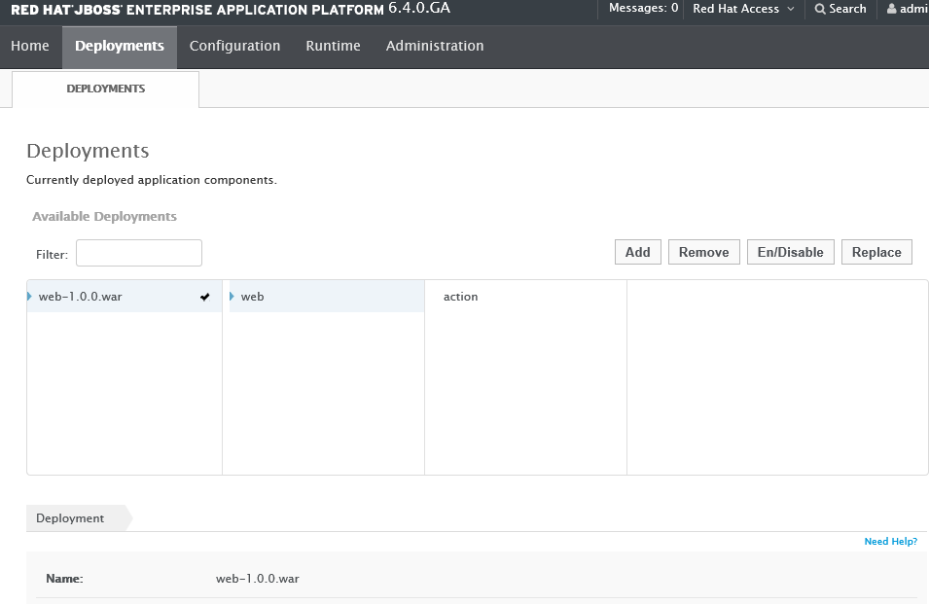

환경설정

C:\dev\jboss-eap-6.4\standalone\configuration\standalone.xml

**<configuration>**

**<jsp-configuration development="true"/>**

**</configuration>**

**기본 root 정보 제거**

**true 🡪 false**

<virtual-server name="default-host" enable-welcome-root="**false**">

<alias name="localhost"/>

<alias name="example.com"/>

</virtual-server>

<socket-binding-group name="standard-sockets" default-interface="public" port-offset="${jboss.socket.binding.port-offset:0}">

<socket-binding name="management-https" interface="management" port="${jboss.management.https.port:9443}"/>

<socket-binding name="ajp" port="8009"/>

<socket-binding name="http" port="**8080**"/>

<socket-binding name="https" port="8443"/>

<socket-binding name="remoting" port="4447"/>

<deployments>

<deployment name="**web-1.0.0.war**" runtime-name="**web-1.0.0.war**">

<content sha1="361727e730cdff32a0c2db39a12b265ec04aa51d"/>

</deployment>

</deployments>

web,xml 동일위치 **jboss-web.xml (Context 변경)**

<?xml version="1.0" encoding="UTF-8"?>

**<jboss-web>**

**<context-root>/ </context-root>**

**</jboss-web>**

<http://localhost:8080/openapi.do?_type=xml>

**jboss - CLI 배포**

>connect

-- 현재 디플로이 된 내용 확인

 Listening on 127.0.0.1:9999 deploy

-- 서버에 즉시 배포

deploy ../Helloworld.war

deploy C:\eGovFrameDev-2.7.1-64bit\workspace\openapi\target\web-1.0.0.war

-- 배포하고 활성화

deploy ../Helloworld.war --disabled

deploy --name=Helloworld.war

-- 재배포

deploy -f ../HelloWorld.war

=====================================

도메인 으로 애플리케이션 배포

=====================================

deploy HelloWorld.war --all-server-groups

undeploy  HelloWorld.war --all-relevant-server-groups

11:58:54,664 ERROR [org.apache.catalina.core.ContainerBase.[jboss.web].[default-host].[/stbd].[action]] (http-/127.0.0.1:8080-1) JBWEB000235: Allocate exception for servlet action: org.xml.sax.SAXParseException: cvc-complex-type.2.4.c: The matching wildcard is strict, but no declaration can be found for element 'mvc:annotation-driven'.

**dispatcher-servlet.xml**

http://www.springframework.org/schema/mvc http://www.springframework.org/schema/mvc/spring-mvc-3.0.xsd"

cvc-complex-type.2.1: Element 'mvc:annotation-driven' must have no character or element information item [children], because the type's content type is empty.

http://www.springframework.org/schema/mvc http://www.springframework.org/schema/mvc/**spring-mvc-3.1.xsd**